**13.9 Applications of Extrema**

Table of Contents

Hessian Matrix 4

Least Squares Method 6

Consider that we have a **rectangular box** that is resting on the $xy$ **plane**, with one vertex at the **origin** and the opposite vertex on the **plane $6x+4y+3z=24$** .

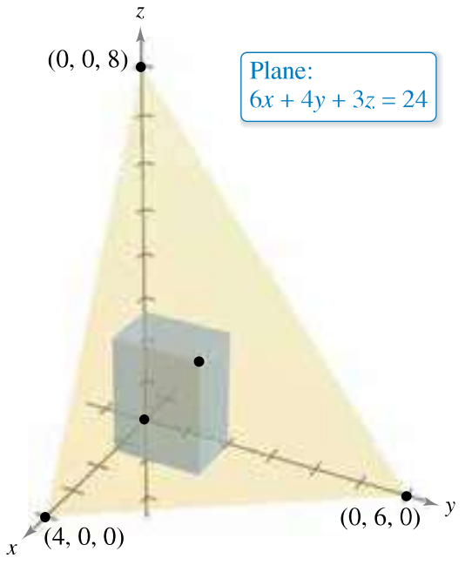

We want to find the **maximum possible volume** of the box.

Let $x$, $y$ and $z$ represent the length, width and height of the box. We can write the equation as:

$$z=8-2x-\frac{4}{3}y$$

Then, the **volume** of the box can be written as:

$$V\left(x, y\right)=\left(x\right)\left(y\right)\left(8-2x-\frac{4}{3}y\right)$$

$$=8xy-2x^{2}y-\frac{4}{3}xy^{2}$$

From here,

$$V_{x}\left(x, y\right)=y\left(8-4x-\frac{4}{3}y\right)=0$$

$y=0$, $x=2-\frac{1}{3}y$

$$V_{y}\left(x, y\right)=x\left(8-2x-\frac{8}{3}y\right)=0$$

$x=0$, $x=4-\frac{4}{3}y$

Thus, there are four possible **critical points**, $\left(0, 0\right)$, $\left(4, 0\right)$, $\left(0, 6\right)$, $\left(\frac{4}{3}, 2\right)$, from the four possible combinations of the above results.

Since the volume is $0$ at the first three of these points, those cannot be critical points. Thus, the **maximum value** must occur at $\left(\frac{4}{3}, 2\right)$. The volume at this point is

## Hessian Matrix

Consider that we have an equation $z=f\left(x, y\right)$. This equation has two possible derivatives, $z_{x}=\frac{δz}{δx}$ and $z_{y}=\frac{δz}{δy}$. It also has four possible **second derivatives**, $z_{xx}=\frac{δ^{2}z}{δx^{2}}$, $z_{yy}=\frac{δ^{2}z}{δy^{2}}$, $z_{xy}=\frac{δ^{2}z}{δyδx}$ and $z_{yx}=\frac{δ^{2}z}{δxδy}$.

We can create a **matrix** using the **four second derivatives** as follows:

$$H_{z}=\left[\begin{matrix}\frac{δ^{2}z}{δx^{2}} & \frac{δ^{2}z}{δxδy} \\ \frac{δ^{2}z}{δyδx} & \frac{δ^{2}z}{δy^{2}}\end{matrix}\right]$$

This is called the **Hessian Matrix**. It is used to determine **maxima** and **minima** for multivariable equations.

We will be taking **partial matrices**, which are just submatrices.

$$Δ_{1}=\frac{δ^{2}z}{δx^{2}}$$

$$Δ_{2}=\frac{δ^{2}z}{δx^{2}}⋅\frac{δ^{2}z}{δy^{2}}-\frac{δ^{2}z}{δyδx}⋅\frac{δ^{2}z}{δxδy}$$

If $Δ_{1}>0$ and $Δ_{2}>0$, we have a **minima**.

If $Δ_{1}<0$ and $Δ_{2}>0$, we have a **maxima**.

If $Δ_{2}<0$, we have a **saddle point**, which is a point which has neighbouring points that are less and also neighbouring points that are greater.

We can extend this to accommodate **three variables** as well:

$$H_{F}=\left[\begin{matrix}\frac{δ^{2}F}{δx^{2}} & \frac{δ^{2}F}{δxδy} & \frac{δ^{2}F}{δxδz} \\ \frac{δ^{2}F}{δxδy} & \frac{δ^{2}F}{δy^{2}} & \frac{δ^{2}F}{δyδz} \\ \frac{δ^{2}F}{δxδz} & \frac{δ^{2}F}{δyδz} & \frac{δ^{2}F}{δz^{2}}\end{matrix}\right]$$

where if $Δ_{1}$, $Δ_{2}$ and $Δ_{3}$ are all positive, we have a **minima** and if $Δ_{1}$ and $Δ_{3}$ are negative but $Δ_{2}$ is positive, we have a **maxima**.

Going back to the example we did earlier, we simply declared that we had a maximum pointer, but we should also prove this using the **Hessian Matrix**.

$$V_{xx}\left(x, y\right)=-4y=-4\left(2\right)=-8$$

$$V_{yy}\left(x, y\right)=-\frac{8}{3}x=-\frac{8}{3}\left(\frac{4}{3}\right)=-\frac{32}{9}$$

$$V_{xy}\left(x, y\right)=V_{yx}\left(x, y\right)=8-4x-\frac{8}{3}y=8-4\left(\frac{4}{3}\right)-\frac{8}{3}\left(2\right)=-\frac{8}{3}$$

$V_{xx}\left(x, y\right)V_{yy}\left(x, y\right)-{\left[V_{xy}\left(x, y\right)\right]}^{2}=\frac{64}{3}>0$ and $V_{xx}<0$, which makes this a **maximum point**.

## Least Squares Method

We have previously used the **Least Squares Method** to determine the **line of best-fit** for several points on a graph. We were trying to reduce the **distance** between the given points and the line.

For a given set of points, $\left\{\left(x_{1}, y_{1}\right), \left(x_{2}, y_{2}\right),…,\left(x_{n}, y_{n}\right)\right\}$, we can determine the line of best fit as $f\left(x\right)=ax+b$, where

$$a=\frac{n\sum_{i=1}^{n}{x_{i}y_{i}}-\sum_{i=1}^{n}{x_{i}}\sum_{\left(i=1\right)}^{n}{y_{i}}}{n\sum_{i=1}^{n}{x_{i}^{2}}-{\left(\sum_{i=1}^{n}{x_{i}}\right)}^{2}}$$

$$b=\frac{1}{n}\left(\sum_{i=1}^{n}{y_{i}}-a\sum_{i=1}^{n}{x_{i}}\right)$$